74

Connections to Learning
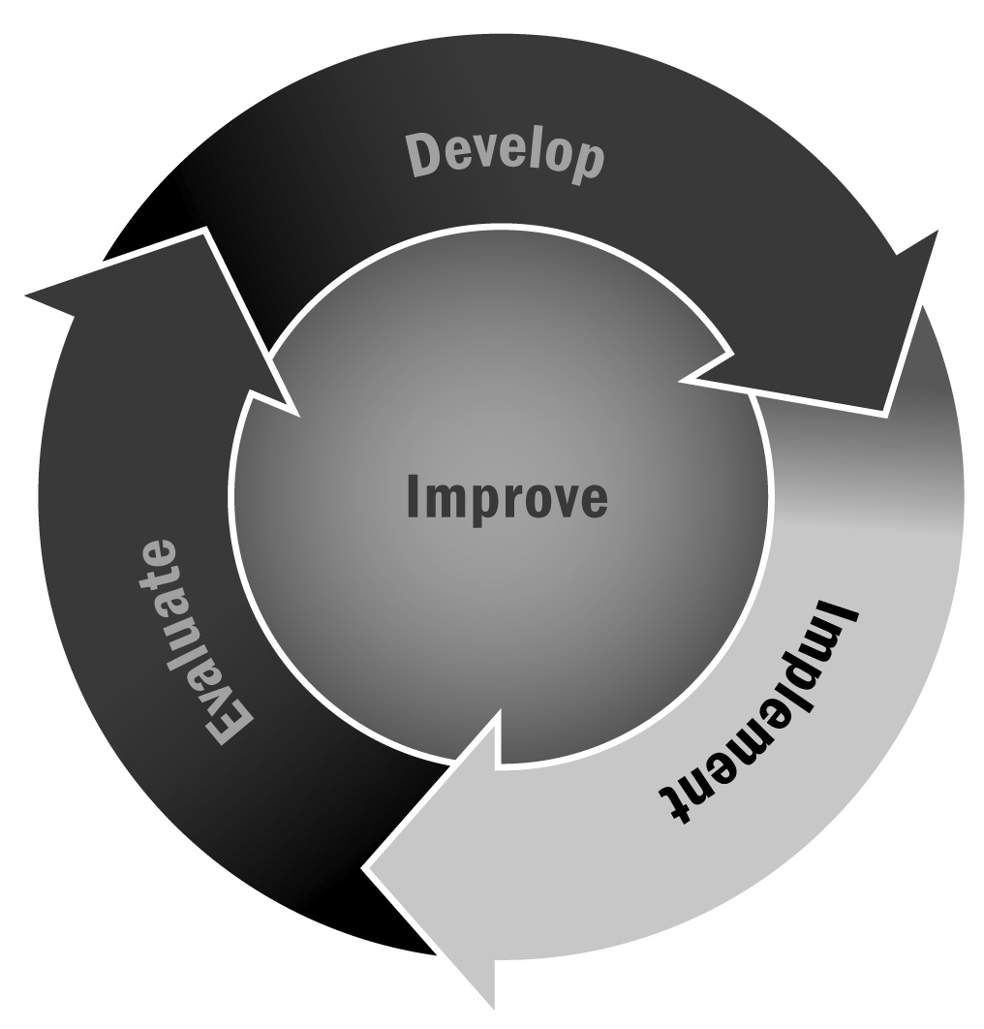
In Chapter 4, you learned about the variety of programming you can offer in afterschool and expanded learning programs and got some ideas of what types of programs to offer. One of the most important things a program can do is make learning fun and engaging and build academic content into a range of program types.
Directions: This tool provides some examples of how you can integrate academic content and connections to various disciplines into several common afterschool and expanded learning programs. These are just suggestions to get your creative juices flowing. Use these or come up with your own. There are many ways to bring academic content or concepts into fun, engaging afterschool and expanded learning programs.

How Can I Make the Connection to Learning…
 | In Math? | In English Language Arts? | In Science? | In History?
Art projects | Geometry through mosaics | Illustrating stories | Eye science | Art history
Comic book design | Plotting the story on graph paper | Writing text to accompany illustrations | Illustrating a scientific concept | History of comics
Gardening | Planning space for garden | Reading about plant care | How things grow | WWII victory gardens
Cooking | Measuring ingredients | Reading recipes | How ingredients interact | History of certain foods or cultures
Journalism | Calculating subscriptions | Writing stories, editing, reading | Environmental monitor | The history of newspaper
School store | Budgeting | Creating flyers | Selling equipment related to science class | Economic history
Theater | Calculating ticket sales | Reading or writing a script | A play about a famous scientist | Read historical plays
Photography | Shutter speeds | Photojournalism | Film developing | Use of photography during wartime
Baseball | Baseball statistics | Reading stories of famous players | Effect of wind speed on the game | History of the sport

